Summary
This paper discusses schemes to protect the stunt person with a stack of boxes. We develop two models for the problem. Model I involves 3D simulation while Model II is a 2D model. Both of them treat boxes as basic elements in computation.
In Model I, we analyzed the physical properties of the box. A box has three states: uncompressed, partly compressed, and fully compressed. We record the size, position, mass and velocity, and state of each object, and calculate the motion and collision of the objects at each time step. In order to study the stability of the model, we discussed different entering points of the motorcycle.
In Model II, each box is treated as a sphere in the computation of collision. This model is simple, but is suitable for testing modifications on the box.
We calculated the appropriate size and number of boxes to use, and discussed the effects of different ways of stacking boxes. At last, we discussed generalizations and further improvements of our models.

The Stunt Person

The Problem
An exciting action scene in a movie is going to be filmed, and you are the stunt coordinator! A stunt person on a motorcycle will jump over an elephant and land in a pile of cardboard boxes to cushion their fall. You need to protect the stunt person, and also use relatively few cardboard boxes (lower cost, not seen by camera, etc.).

Your job is to:
* determine what size boxes to use
* determine how many boxes to use
* determine how the boxes will be stacked
* determine if any modifications to the boxes would help
* generalize to different combined weights (stunt person & motorcycle) and different jump heights

Note that, in "Tomorrow Never Dies", the James Bond character on a motorcycle jumps over a helicopter

Restatement of the Problem
Hardly a movie made today is without some kind of amazing stunt work. We all are held breathless when a person falls out of a 20-story building or when a heart-stopping car chase ends in a spectacular crash.
To reduce the chances of damage or injury, stunt designers use devices that stretch out the time it take to stop a body's momentum. The longer the period of time used in changing the momentum, the less force will be released upon impact. The cardboard boxes are one of the devices used.

Our task is to:
① determine what size boxes to use
② determine how many boxes to use
③ determine how the boxes will be stacked
④ determine if any modifications to the boxes would help
⑤ generalize to different combined weights (stunt person & motorcycle) and different jump heights

Basic Assumptions

(1) The area where the cardboard boxes are stacked is flat and without any obstacles.
(2) During the entire process, the stunt person & motorcycle are considered as a whole object.
(3) The cardboard boxes are approximately considered as cuboids.
(4) Compared to the resistance of the boxes, the air’s is very slight and can be neglected.

Symbols
 the bounce coefficient of the box
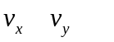 the component of velocity along axis
compression of the box
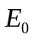 the kinetic energy the box absorbs when it turns into compact body

Analysis of the Problem and Model Design

When the motorcycle crash into the boxes, the motorcycle collides with the boxes, forces the boxes into motion. The boxes, in return, exert forces on the motorcycle, thus cushion the movement of the motorcycle. Though the interactions between the boxes and the motorcycle are very complicated, they can mainly be divided into two kinds: friction and elastic force. They are forced by the friction, the bounce, the gravity, even inside the box there are the tension, the pull and so on. Since this problem involves discontinuous mechanical behavior, we adopt the Discrete Element Method in our model design.

Model Ⅰ:

We analyze what will happen when a cardboard box is compressed: If the compression is slight, the cardboard box maintains its structure and strength; the compression of the box is restorable. When the compression increases, the resistance of the cardboard box gets stronger. When the compression gets too big that the cardboard box cannot hold its structure, the structure breaks and the box begins to collapse. A collapsing box only has negligible strength to resist further compression until most of the air in the box is expelled out of the cardboard box and the box turns into a compact body. Then the resist-compression curve of the box becomes so steep that it cannot be further compressed. The relation of the resist force and the compression of a box can be illustrated in the graph below.
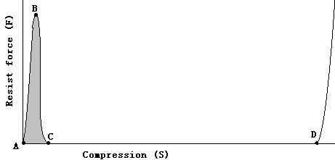

Fig.1 The relation of the resist force and the compression of a cardboard box
A—B: Restorable compression;
B—C: The box begins to collapse;
C—D: Collapsing;
D— : The box turns into a compact solid

Let be the kinetic energy the box absorbs when it turns into compact body. We can calculate the energy absorbed by the box from point A to C which is close to using the formula below:
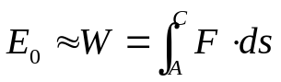 (1)
Note that this is the area of the shadow.
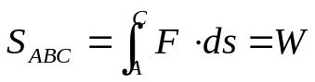 (2)
Thus a box absorbs a definite amount of kinetic energy when it is compressed from point A to point C. Compared to the time of the whole process, the time from A to C is so short that it can be neglected. When the compression reaches point D, the resist force increases so sharply that we can treat the box as a rigid body. Therefore, we design the following model.

A box is modeled as a trio-state cuboid that is compressible when it is at the “uncompressed” state and the "partly compressed" state, and becomes a rigid body when it is at the "fully compressed" state. An uncompressed box maintains its original shape and volume, and turns into “partly compressed” when pressed by another object and absorbs a certain amount of kinetic energy of the object. A partly compressed box can be staved and compressed into a smaller cuboid without exerting any friction and elastic force to other objects, and turn into the compressed state when its volume decreases to a certain limit. The stunt man and the motorcycle are modeled as one rigid cuboid that crashes into the boxes. When it collides with a box, it compresses the box and turns the box into the compressed state, a rigid cuboid, which then interacts with the stunt man and motorcycle conforming the collision law. The box decelerates the man & motorcycle, while the man & motorcycle forces the box into movement, which then collide with other boxes. When the man & motorcycle moves on, it collides with more boxes, decelerating along the way, and eventually stops moving. The whole process of the man & motorcycle colliding with a box is illustrated in Fig.2.

Man & Motorcycle

Man & Motorcycle

Box
Box

(b)
(a)

Man & Motorcycle

Man & Motorcycle

Box

Box

(d)
(c)

Man & Motorcycle

Box

(e)

Fig.2. The man & motorcycle colliding with a box
(a) The man & motorcycle moves towards the uncompressed box.
(b) When the man & motorcycle contacts the box and begin to compress it, turn it from uncompressed into partly compressed, the box absorbs a definite amount of the kinetic energy of the man & motorcycle.
(c) The man & motorcycle continues to compress the box, the box is in the partly compressed state, and exerts no force on the man & motorcycle.
(d) The volume of the box decreases to the limit and turns into the compressed state (a rigid body) and collides with the man & motorcycle.
(e) The compressed box is forced into movement by the collision, while the man & motorcycle is decelerated by the box.

In this model, the movement of the man & motorcycle is influenced by gravity and collision with boxes; the movement of a compressed box is influenced by gravity, collision with man & motorcycle, collision with other boxes and ground support & friction if it contacts the ground, while an uncompressed box can be only influenced by gravity and support from boxes below or from the ground before it turns into compressed state. A computer program is used to calculate all of these influences and to simulate the cushion process of the boxes.

In the computer program, the stunt man and motorcycle are represented as one object. All the boxes are represented as objects, too. Each object holds its size, position, mass and velocity, and each box object has a variable that represents its current state (compressed or not). The motion of each object is calculated each time step. At each step, every object is moved and checked if it collides with other object, if no collision happens to the current object, the state of the object is determined by the formula below:
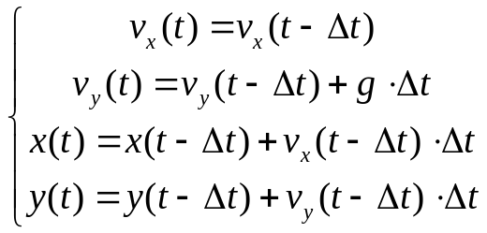 (3)

If collision happens to the current object, the program calculates the reaction of the colliding objects based on their mass, speed and state (compressed or not). This is divided into three conditions:

Condition Ⅰ: The current object collides into an uncompressed box; if the collision not hard enough, the box remains uncompressed and the standard collision law applies, otherwise, the uncompressed box turns into partly compressed and absorbs a certain amount of energy. The strength of a cardboard box is usually calculated with the following McKee formula:

 (4)
FC = Flute Constant ECT = Edge Crush Test
BP = Box Perimeter SF=Shape Factor
LWRF=Length to Width Ratio Factor
HFF=Horizontal Flute Factor PF=Printing Factor

We use this formula to estimate the value of energy absorbed() in our program.
Condition Ⅱ: The object collides into a partly compressed box, because a partly compressed box does exerting any force to other objects, the current object moves exactly as if no collision is happening. So formula (3) is applied.
Condition Ⅲ: The object collides into a fully compressed box or the man & motorcycle, and if the current object itself is an uncompressed or partly compressed box, then Condition I or Condition II applies to the fully compressed box or the man & motorcycle. If the current object is also a fully compressed box or the man & motorcycle, then a solid collision happens and the formula below applies:
y
Obiect1

x
Object2

Fig.3. The position of the two objects.

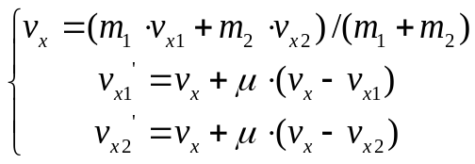 (5)
where is the bounce coefficient.
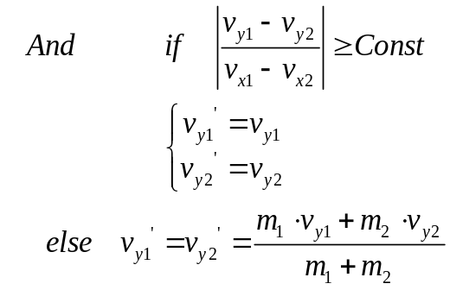 (6)
Based on the analysis above, we have designed a program in Visual C++ to simulate the whole process. Our program mainly consists of two parts:
(1) Tracing and calculating of the position and speed of the boxes and the motorcycle. (2) Graphic visualization.
Results of Model I:
- The best size of boxes:
According to the Chinese standards of corrugated boxes, the density of a box is 0.68kg/m², so we can calculate the mass of a box according to the following formula:
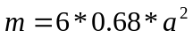 (7)
where is the side length of a box. And the energy absorbed when a box begins to collapse is proportional to . We use different sizes of boxes to simulate the whole process, and recorded the decelerating rate of the man & motorcycle.
When the boxes are small( = 15cm), the vertical deceleration is very fast, so only the upper part of the box stack is affected by the man & motorcycle, other boxes are not affected so does not decelerate the man & motorcycle. The following graph illustrates the process:
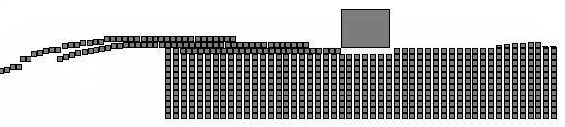
Fig.4 15 cm boxes cushion the man & motorcycle
in this graph, the large box represents the man & motorcycle which is 150kg and has jumped over a 6 meter height(over an elephant) with a 20 m/s horizontal speed(from right to left). At the time of the graph, the vertical speed is reduced to 4m/s, but the horizontal speed is as fast as 15 m/s, and the horizontal speed can not be reduced below 12 m/s before the man & motorcycle lands on the ground, which is very dangerous.
When the boxes are big( = 50cm), the vertical deceleration is not enough to provide a safe landing. The following graph illustrates the process:
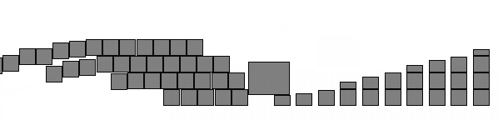
Fig.5 50cm boxes cushion the man & motorcycle
In this graph, the same man & motorcycle jumped the same height with the same speed as in Fig.4, but the sizes of the boxes changed from 15cm to 50cm. At the time of the graph, the horizontal speed has been reduce to 9m/s, but the vertical speed is as big as 6m/s. the man & motorcycle strikes hard against the ground with a vertical speed that is equal to a fall from 2m height, which is not so safe.
We simulated with varied sizes of boxes, and found that 30cm boxes provide the best landing, which is 8m/s horizontal speed and 3m/s vertical speed. A horizontal speed of 8m/s is equal to jumping down from a running bicycle, which is very safe. The whole process is illustrated in the following graphs:
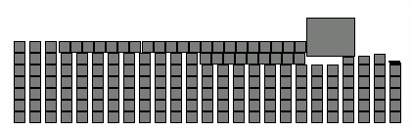
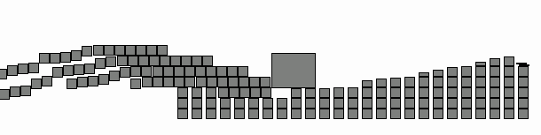

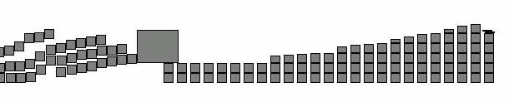
Fig.6 30cm boxes cushion the man & motorcycle

The decelerating process is like this:

Time(second) | Horizontal speed(m/s) | Vertical speed(m/s) | State
0.100250 | 20.000000 | 0.959881 | Free Fall
0.200500 | 20.000000 | 1.948995
0.300750 | 20.000000 | 2.936112
0.401000 | 20.000000 | 3.923900
0.501000 | 20.000000 | 4.902236
0.601000 | 20.000000 | 5.884290
0.701000 | 20.000000 | 6.868512
0.801000 | 20.000000 | 7.847865
0.901056 | 19.747498 | 8.465098 | Plunge into the boxes
1.001070 | 17.868766 | 7.035899
1.101088 | 16.061376 | 6.159321
1.201099 | 14.805625 | 5.939486
1.301102 | 13.972497 | 4.851302
1.401119 | 12.883934 | 4.626583
1.501120 | 12.268939 | 3.938590
1.601121 | 11.454120 | 3.371359
1.701121 | 11.008360 | 3.519011
1.801122 | 10.906639 | 1.552844
1.901125 | 10.310166 | 1.631726
2.001126 | 10.281974 | 2.417273
2.101131 | 10.272263 | 0.404983
2.201131 | 10.251879 | 0.846761
2.301136 | 10.227757 | 1.835473
2.401138 | 10.057645 | 2.815764
2.501145 | 9.937230 | 3.743811
2.601147 | 7.999316 | 0.000000 | Land on the ground

List.1 Deceleration process of the man & motorcycle
The deceleration is very smooth; the boxes cushion the man & motorcycle very well. We conclude that 30cm boxes provide the best all-round deceleration (horizontal and vertical), so it is the box of choice.

- How many boxes should be used?
  - Height of the box stack
We used different height of the box stack and the relation of vertical landing speed and height of the box stack is listed below:

Stack height | Vertical Landing speed
1 | 9.8009232
2 | 7.505732
3 | 6.071627
4 | 4.302166
5 | 2.420890
6 | 2.231104
7 | 1.986893

The vertical landing speed decreases when the height of the stack increases. And we can conclude from the list that stack height 5 is enough to decelerate the man & motorcycle in the vertical direction. Further increase the stack height does not provide significant more safety.

  - Length of the box stack
We used different length of the box stack and the relation of horizontal landing speed and length of the box stack is listed below:

Stack length | Horizontal landing speed
5 | 17.862923
10 | 15.226120
15 | 12.549519
20 | 10.557690
25 | 9.248788
40 | 7.696714
75 | 4.733869

The horizontal landing speed decreases when the length of the stack increases. The list shows that when stack length increase to 25, the speed is already safe for the man & motorcycle to land, and there is only slight difference between the horizontal landing speeds when the stack length increases beyond 25. So we chose 25 as the stack length.

  - Width of the box stack
In the calculations above, we assumed that the box stack is wide enough. We assumed that the width of the motorcycle is 80cm, so it can push 4 boxes simultaneously. So the width of the box stack is at least 4.

  - Further analysis.
Based on the analysis above, we need 5 * 25 * 4 = 500 boxes. But this is based on the assumption that the man & motorcycle enters the box stack from exactly the upper-right corner. In reality, we can specify a area of possible landing area, and stack the boxes based on this area. This is illustrated in the image below:
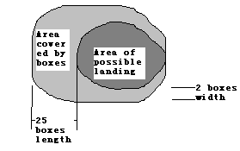
Fig.7 Area covered by boxes(looking from above)
So the amount of boxes should be used is more than 500 and is based largely on the area of possible landing.

- In the simulations above, we stacked the boxes regularly with a 10 cm interval between each row. This interval should be based on the ratio of the horizontal speed and vertical speed of the motorcycle. The interval should increase when the ratio increases, decrease when the ratio decrease, in order to fit the motion track of the man & motorcycle. This is illustrated in the graph below:

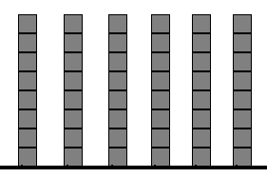
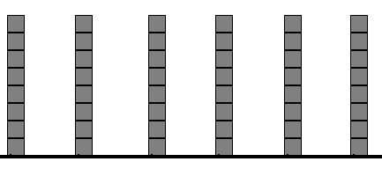

We now give a theoretical analysis of stacking schemes:
Horizontal deceleration of the motorcycle is caused by its collision with boxes in the horizontal direction. Suppose the motorcycle collides with n boxes in time dt.
Mi is the mass of the i-th box, dvi is the change in velocity of the i-th box, f is the total force on the motorcycle.
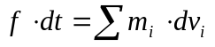
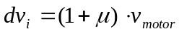，is the elastic coefficient.
，
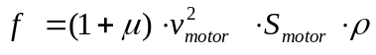
This means 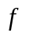 is proportional to 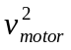. This means is bigger when the motorcycle has just enter the stack. To make the motorcycle decelerate smoothly, we should put less boxes in the front.

- Filling the boxes with soft materials can increase the mass of a box without change other attributes of the box very much. Doing this can make the horizontal deceleration faster and make the horizontal landing speed lower. But if the mass of the box is too much, the deceleration becomes so great that human body cannot endure it. Anyway, unmodified boxes can cushion the man & motorcycle well and cost less. But if the weight of the man & motorcycle becomes very heavy (or replace the motorcycle with a car), filling the boxes to increase their weights is a must.

- If the weight of the man & motorcycle and jump heights varies, we need more or less boxes to cushion it. Because each box always absorbs the same amount of kinetic energy when it begins to collapse, the height of the box stack needed should be proportional to the potential energy of the man & motorcycle when they are at the highest point of the jump. This is verified by simulation of falls from different height and different weight:

Height of jump (m) | 3 | 4 | 5 | 6 | 7 | 8 | 9 | 10
Box stack height needed  (Weight = 150) | 3 | 4 | 4 | 5 | 5 | 6 | 6 | 7
Box stack height needed  (Weight = 300) | 8 | 9 | 10 | 11 | 12
So we can calculate the needed height of the box stack with the following formula:
H = 5 * (W * H) / (150kg * 6m) (8)

H is the needed stack height, W is the combined weight of the man & motorcycle, H is the jump height. This is because we have calculated that an 150kg man & motorcycle combination needs a stack height of 5.
If the weight of the man & motorcycle increases a lot, the boxes should be filled to increase their mass in order to decelerate the man & motorcycle efficiently. The mass of a box should be proportional to the combined weight of the man & motorcycle in order to provide exactly the same deceleration effect to the man & motorcycle:
w = w0 * W / 150kg (9)
where w is the weight of the filled box, w0 is the weight of the empty box, W is the combined weight of the man & motorcycle. This is because empty boxes can decelerate an 150 kg man & motorcycle combination effectively.

Model Ⅱ:

In fact, there are several lines at the same altitude. And those boxes at the same altitude press each other, thus in the following model it is necessary to study how the boxes interact with each other.

When an object (cardboard box or stunt person & motorcycle as a whole) is moving, if the direction isn’t straight, it will press the boxes at the lateral side into lateral movement. But this compression may be very slight. Experiments show that the relation of the resist force and the compression of a cardboard box when the compression is slight can be represented by the following curve: (Fig.4.)
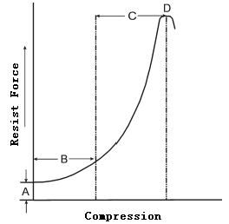
Fig.8. The relation of the resist force and the compression of a cardboard box when the compression is slight (from http://www.ecartonbox.com/industry/wd_02.asp)

There are several formulas to calculate resist force: K.O.Kellicutt formula, Maltenfoit formula, Wolf formula, Mckee formula and so on. But all those formulas involve many indeterminate factors. To avoid complex calculating of the process, we can just study the effect of this process. And the effect is that every box ‘close’ to the moving object gets an impulse. But what does ‘close’ mean, and how to determine the direction and how much the impulse is?
In the model below, the stunt person & motorcycle as a whole is modeled as a sphere. According to the analysis above, it will cause its lateral boxes into movement even if they do not contact each other. Thus the diameter () is set a little lager than its original width. And also the boxes are treated as spheres， while the diameter () is determined according to the compression nature of the box (Fig.1.). Observed above, the whole process takes place in a horizontal plane.

When two spheres meet, they collide with each other(Fig.5.). And their new velocities obey three laws at least:
Law Ⅰ: The normal components (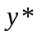 direction) of the velocities satisfy the following formula:
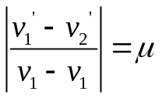 (10)
where is the bounce coefficient.
Law Ⅱ: The momentum conversation law along direction.
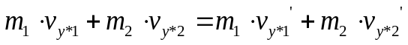 (11)
Law Ⅲ: The shear components (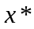 direction) of the velocities do not vary.

y* x*
a

ball 1
α

y
Ball 2
b

x

Fig.9 The two balls collide with each other

The components of velocities can be calculated as follows:
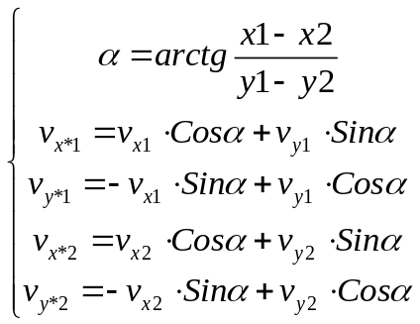 (12)
After collision, the new components of velocities are determined by formulas (10) and (11):
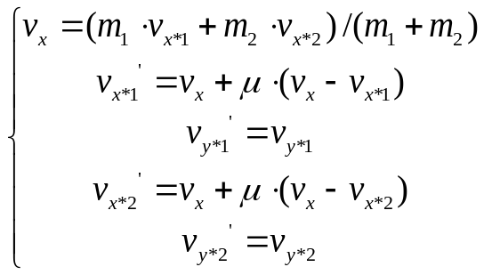 (13)
Thus the new velocity vectors can be calculated from new components of velocities in the x*-y* reference frame:
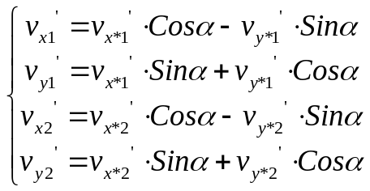 (14)

In our computer simulation, time is divided into intervals of 0.005 second. The position and the speed vector of each object is traced and refreshed at each time step. After a time interval, we calculate the new position of an object according to its last position and speed, and then calculate the gravity force that changes its speed. After that we examine whether it collides with another object, and calculate its new speed vector if collision happens. The program is written in Matlab.

Results of Model II:
We take certain boxes which all the parameters are determined to simulate the process, the following Fig will demonstrate this process
(The motorcycle is represented as a flat, the boxes are represented as small balls):

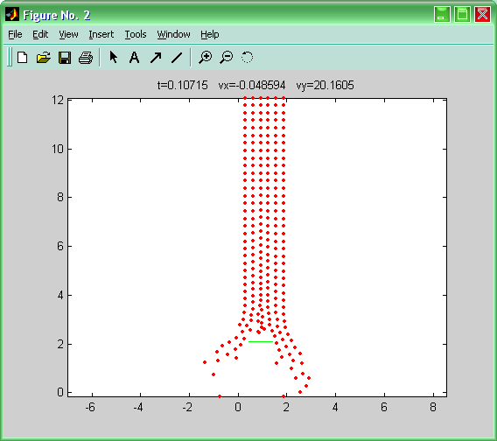

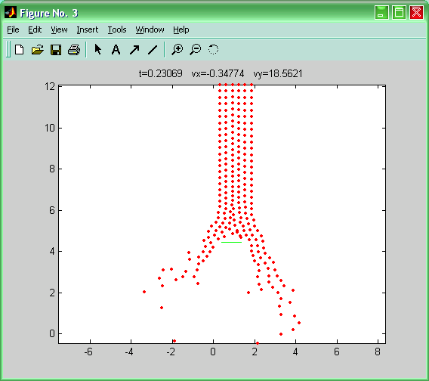

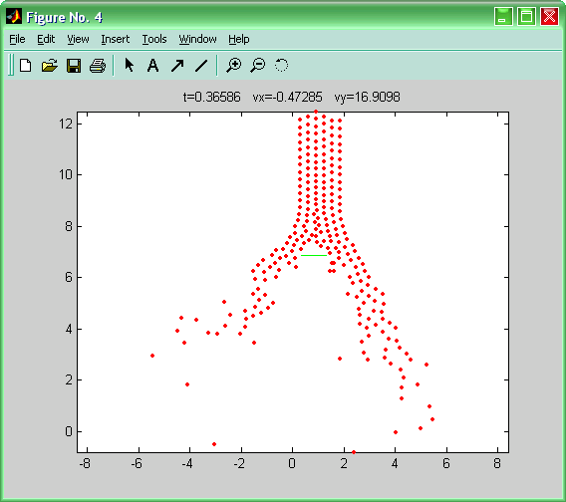

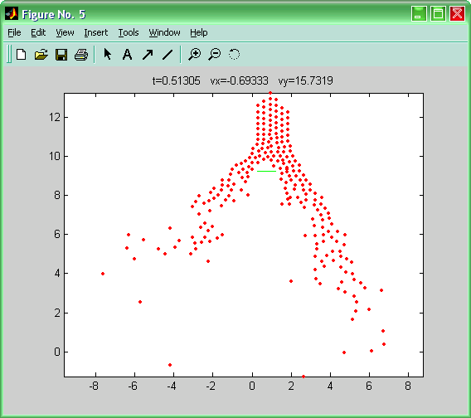

Fig.10 The process of the deceleration of the motorcycle using Model II

At the same time, the program records the acceleration of the motorcycle in the two crossing directions and draws the following Fig:

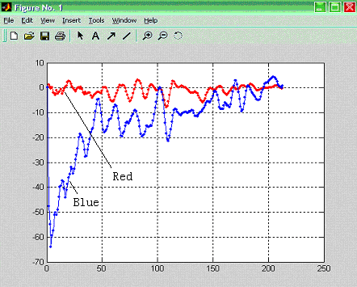

Fig.11. Two accelerations vary as the time goes on
Red curve------ the acceleration in lateral direction
Blue curve----- the acceleration in moving direction

Strengths and Weaknesses of the Models
Model I:
Strengths
(1) The box is treated as an object with three possible states. This treatment is a reasonable simplification according to the experimental results about cardboard boxes. Moreover, it has greatly accelerated computation.
(2) The model involves 3-D simulation. We used improved algorithm to detect collisions, which reduced the time cost of the simulation. (About 30 seconds for a simulation of the complete process)
(3) The model is applicable to different values of parameters, such as combined weights and jump heights.
(4) The versatility of the model is obvious. This model employs a discrete simulation method that can be easily adapted to other applications.
(5) Some parameters of the process can be studied separately, thus the size , the amount of the boxes and so on.

Weaknesses
(1) The rotation of the boxes was not considered in the model. The rotating energy of the boxes comes from the initial kinetic energy of the motorcycle. Since it was not taken into account, we can expect that the motorcycle actually decelerate faster than our calculation.
(2) Collisions of more than two boxes were not considered.
(3) The boxes were considered to be accurate cuboids. But actually they may change their shape under the impact of the motorcycle. We have neglected this effect, thus brought some inaccuracies.

Further Development
As the rotation absorbs kinetic energy which will contribute to the total energy, we can add the rotating of the objects into further consideration.
The change in shape of the boxes are not considered in our models. To solve the problem, we might further analyze the box into many parts, but this will definitely increase computational cost.
In our models we have always assumed that no three objects will collide together at the same time. But this is not true for complex objects such as boxes. Interactions between boxes take time, and it is quite often that two or more of such time intervals overlap. if we treat collision as a process rather than a instantaneous event, we can add collision of many objects in the model.

Model II:
All the objects are treated as uncompessible spheres, then it is easy to refresh the position and velocity of the objects when they collide with each other.
Although the simulation does not involve gravity, it is adaptable when the gravity can be neglected.
The greatest strength of the this model is that it showes how the collision takes place when they do not meet center-to-center.
But this model is quite simple, and neglects too many factor. Although those factors make little effect on the result alone, they do make great effect all together.

Comparison of Model I and II：
Model I treats the objects as cuboids while Model II treats them as spheres. In some sense, spheres better represents the boxes than cuboids do. In Model I, the objects are always cuboids even if compressed, and they can only collide on the horizontal or vertical direction, but actually they can rotate and change their shape. This effect is especially apparent for small boxes. Therefore Model II provides a platform on which we can test different shapes of boxes. Though we did not test many kinds of modifications on the shape of the box, it is already seen that spheres and cuboids bring about different results. An example is that, in Model II, more boxes near the entering point of the motorcycle move under the impact of the motorcycle than in Model I.
Another difference is that Model II is a 2D model. It does not involve gravity force. It is a model suitable for studying the nature of the stack of boxes, which can be viewed as a kind of granular matter. We suggest using a 2D model to get some knowledge about the dynamic properties of the boxes. This is time-saving and will help us establish 3D models easier.

References：
1.Acceleration, http://www.db.erau.edu/campus/departments/aas/beltran/acceleration.ppt
2. Stacking Strength, http://www.topseng.com/T_Stack.pdf

